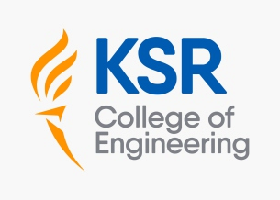

DEPARTMENT OF MECHANICAL ENGINEERING

Innovation by the Faculty in Teaching and Learning
- In order to achieve better learning outcomes, innovation takes place in a particular teaching and learning context, either by introducing a new practice or by refining the application of the existing practice. It has a broad function and is essential for all educators to fulfil the educational demands of the next generation.
- Innovative teaching approaches enable instructors to present their lectures more quickly and effectively, enabling students to stay up to date with technology developments. Additionally, by encouraging students to be more proactive, new teaching tools help them develop logical thinking and self-sufficient mental processes.

Usage of ICT Enabled Tool

- Teachers use ICT enabled tools for effective teaching-learning processes.
- ICT helps the faculty to represent their content in a more demonstrative manner.
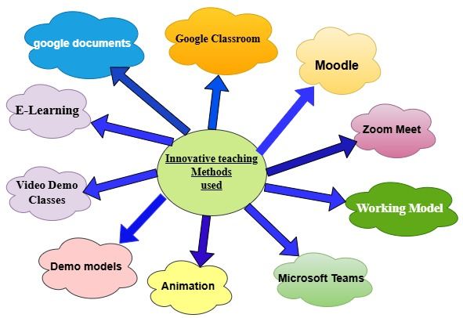

Figure 5.6.1 Innovative teaching methods used.
The lists of innovative teaching techniques adopted in the department are tabulated below:

S.No | Innovation Method | Mode of Teaching/Learning Process | Objective
1. | Google Classroom | Online Tool/Blended learning | Simplify creating, distributing, and grading assignments and sharing files between faculty and students
2. | Moodle | Online test tool | Alternative method to assess the students through curriculum at anytime from anywhere
3. | Zoom Meet | Online tool | Zoom meetings for students enable real-time interaction, allowing virtual classes, discussions, and collaborations. It provides a flexible platform for remote learning and direct communication with instructors
4. | Working Model | Demonstration of  working model of the project | Enhances the knowledge towards  hardware aspect
5. | Microsoft teams | Online tool | Microsoft Teams for students provides a collaborative platform for organizing assignments, meetings, and discussions. It helps students communicate, share files, and work on group projects in a unified space
6. | Animations Video | Online | Animation videos for students enhance learning by visualizing complex concepts, making them more engaging and easier to understand through dynamic and interactive content.
7. | Demo Models | Demonstration of  demo model showcase in Lab . | A demo model helps students visualize theoretical concepts in practice, providing hands-on experience to reinforce learning. It simplifies complex ideas, making them more tangible and easier to grasp
8. | Video demo class | Online class | A video demo class provides students with visual and auditory learning experiences, demonstrating key concepts in an engaging way. It allows students to review material at their own pace for better understanding.
9. | E-Learning | NPTEL / Coursera | Upgrade the quality of Engineering education and using resources beyond the curriculum
10. | Google document | Online | Google Documents allows students to collaboratively work on and share projects, making real-time edits and feedback possible. It provides an accessible platform for instructors to review and track project progress.
11. | Flipped Classroom | Offline | The objective of the flipped classroom is to shift traditional learning outside the classroom, allowing students to engage with content independently and use class time for active learning and application.
12. | Student-Centric teaching methodologies | Offline | The objective of student-centric teaching methodologies is to foster active engagement and critical thinking by placing students at the center of the learning process. It aims to promote personalized learning, allowing students to explore, collaborate, and apply knowledge in meaningful ways.
1.Google Classroom
Google Classroom is a free blended learning platform for educational institutions and it is an essential technique that aims to simplify creating, distributing and grading assignments.
The primary purpose of Google Classroom is to streamline the process of sharing files between teachers and students. Google Classroom is a suite of online tools that allows teachers to set assignments, have work submitted by students, to mark and to return graded papers. Administrator invites the teachers and students using their individual mail id as a user name to be a member of the classroom.

Utilization of Google Classroom for Students
Based on Anna University curriculum and autonomous syllabus the course wise materials are uploaded which is in the form of pdf, doc & PPTs for all second, third and final year students.
- Similarly, Question banks for individual courses including Part A, Part B and Part C questions with solutions for students are also uploaded. This provides guidelines for their last minute University exam preparation.
- Previous year Anna university question papers are uploaded with solutions and Lecture videos are uploaded to visualize the concepts.
- Assignments can be assigned by the faculty to the students and later it can be evaluated and graded accordingly.
- Provides a platform to communicate test circular, college and department event details, placement details. The official information would reach the concerned and the same would be notified to the sender.

- All the faculty members of the Department of Mechanical Engineering use Google Classroom extensively and a sample page is shown below in Figure 5.6.2
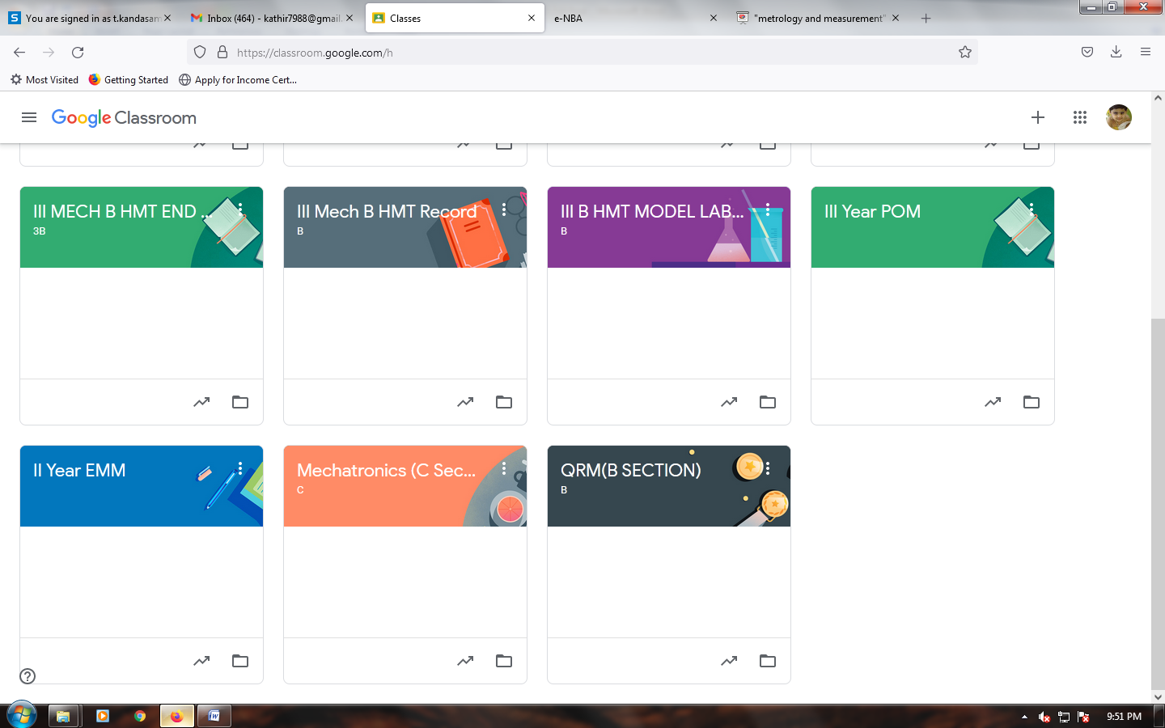

Figure 5.6.2 Google class room sample
2.Moodle
Moodle is a versatile Learning Management System (LMS) that provides a wide range of features to enhance the learning experience for students.
1. Access to Course Materials
Students can access lecture notes, study materials, multimedia content (videos, audio), and readings in a single location. Teachers can upload assignments, slideshows, readings, and links to external resources, which students can view or download for study purposes.

2. Assignments and Quizzes
Students can submit assignments and projects directly through Moodle, including text, file uploads, or multimedia formats. Students can take quizzes and assessments, which can be automatically graded, providing instant feedback.
3. Communication and Collaboration
Discussion Forums: Moodle provides forums for students to discuss topics, ask questions, and interact with their peers and instructors. Students can send direct messages to their instructors or fellow students for queries or collaboration.

4. Tracking and Monitoring Progress
Students can view their grades for assignments, quizzes, and courses. This feature allows students to track their progress and identify areas for improvement. Moodle allows teachers to set completion criteria for various activities. Students can see what tasks they have completed and what is still pending.

5. Learning Activities
Moodle offers various interactive learning activities like wikis, assignments, and peer assessments. These tools help engage students in active learning. Students can collaborate on group assignments and projects using shared resources, discussion boards, and collaborative workspaces.

6. Access to Course Calendar and Deadlines
Moodle includes a calendar where students can track important dates, such as assignment deadlines, exam dates, and course events. Moodle sends automatic reminders about upcoming assignments, quizzes, or forum discussions to keep students informed.

Department is using MOODLE for conducting online assessments. Student and faculty members of Institution can access the MOODLE services from inside the campus by using the URL: http://172.16.1.2/moodle/. and sample picture shows in figure 5.6.3.
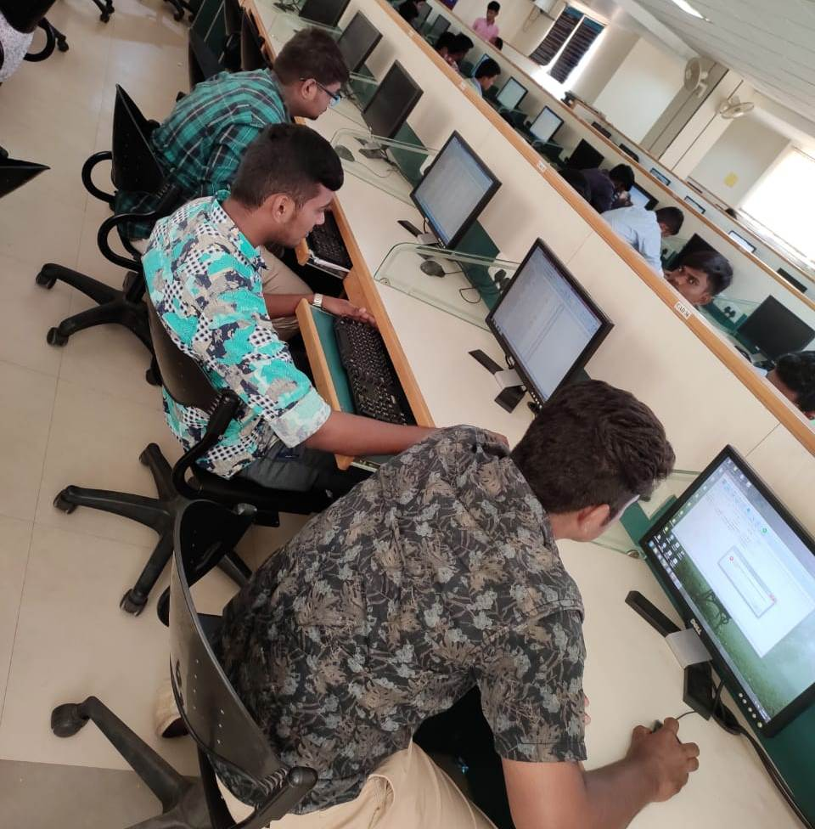

Figure 5.6.3 Moodle tool use in Lab
3. Zoom Meet
Zoom meetings provide students with a platform for live, interactive learning, where they can engage with instructors in real-time. It allows teachers to conduct virtual lectures, presentations, and discussions, ensuring that students remain connected despite being physically distant. Through features like screen sharing and virtual whiteboards, instructors can present material visually, enhancing understanding.
Zoom also enables students to ask questions and participate in discussions, promoting active engagement during lessons. Breakout rooms allow students to collaborate in smaller groups, fostering peer interaction and teamwork. Students can attend office hours or one-on-one sessions with instructors for personalized guidance.
The chat function lets students share thoughts, resources, or links during the meeting. With recording options, students can revisit lectures at their own pace for better comprehension. Zoom integrates with other tools, such as Google Drive and Moodle, to share resources seamlessly. Overall, Zoom meetings support flexible, accessible, and engaging learning experiences for students, no matter their location.
Figure 5.6.4 show image student’s active participation and interaction with faculty
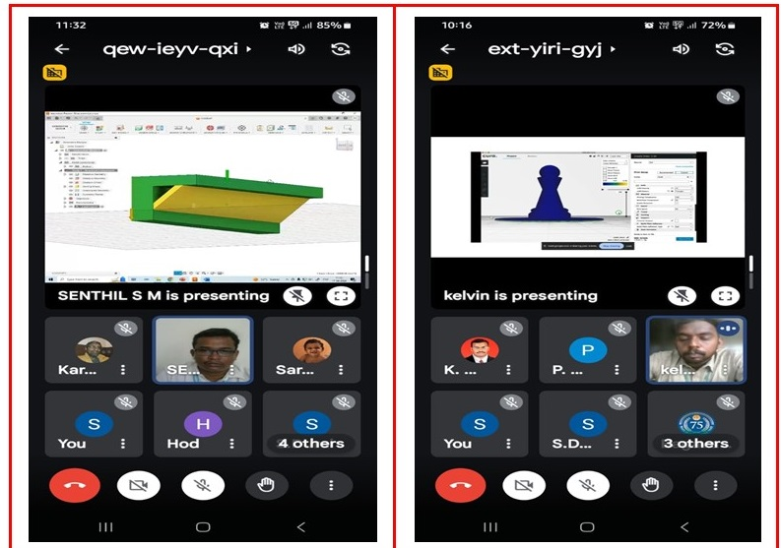

Figure 5.6.4 Zoom meeting student’s active participation and interaction with faculty

4. Working Model
A working model for students helps them better understand theoretical concepts by providing hands-on experience and visual demonstrations. It simplifies complex ideas, allowing students to observe the application of principles in real-world scenarios.
By constructing or interacting with the model, students can experiment, test hypotheses, and refine their understanding. This active learning approach enhances critical thinking and problem-solving skills. Working models also make learning more engaging, encouraging curiosity and exploration.
Students can identify mistakes and correct them in real time, reinforcing the learning process. These models support experiential learning, where knowledge is gained through direct experience. Overall, working models bridge the gap between theory and practice, making abstract concepts more tangible and easier to comprehend.
Figure 5.6.5 shows working models for project.
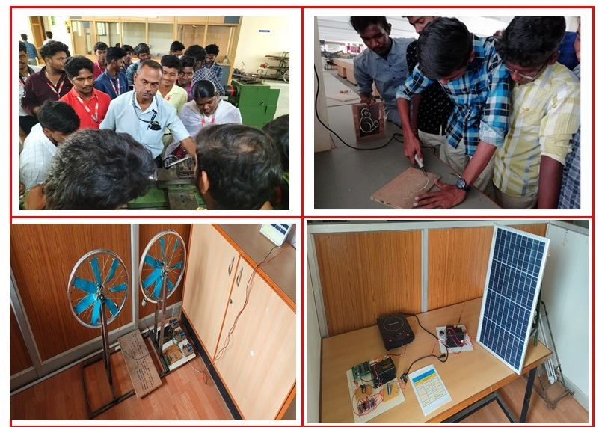
Figure 5.6.5 Working demo models in Lab

5. Microsoft Teams
Microsoft Teams provides students with a centralized platform for communication, collaboration, and learning. It allows students to join live classes, attend virtual discussions, and participate in group projects. With integrated tools like file sharing, real-time document editing, and task management, students can work collaboratively on assignments and share resources seamlessly.
Teams also enables students to organize and track their learning activities through channels and calendars, ensuring they stay on top of deadlines. Students can use the chat feature for quick queries or peer interaction, enhancing communication. Additionally, assignments and grades can be managed within Teams, offering students easy access to feedback. Overall, Microsoft Teams fosters a collaborative, organized, and efficient learning environment for students.
Figure 5.6.6 shows image student’s active participation and interaction with faculty.
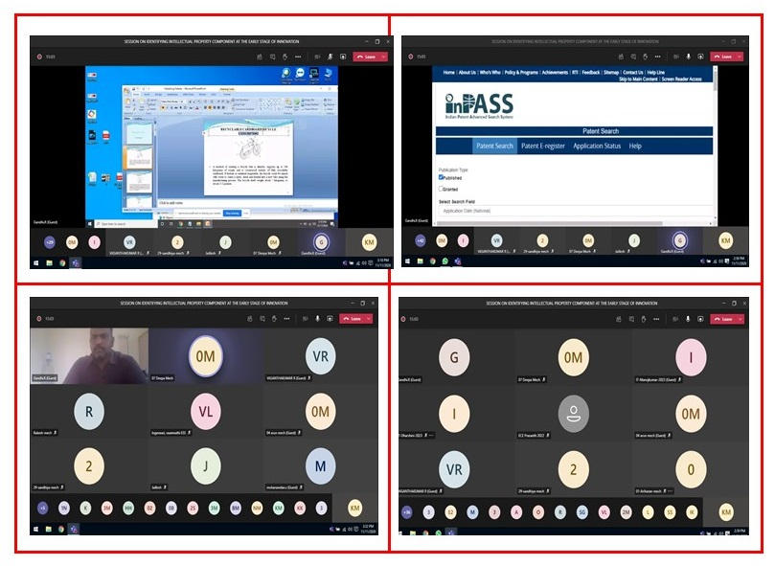
Figure 5.6.6 Microsoft teams meeting with student’s active participation.

6. Animations Video
Animation videos are an effective tool for student learning, as they simplify complex concepts through engaging visual storytelling. They can break down abstract or difficult topics into easy-to-understand animations, making learning more accessible.
The dynamic and colorful nature of animation captures students' attention, enhancing focus and retention. Animation videos also provide a multisensory experience, appealing to both visual and auditory learners.
They can be paused, replayed, or slowed down, allowing students to learn at their own pace. Additionally, animated videos can incorporate interactive elements, quizzes, or questions to reinforce learning. Overall, animation videos offer an engaging and effective method to enhance students' understanding and knowledge retention.
Figure 5.6.7 shows image student’s active participation and interaction with faculty.
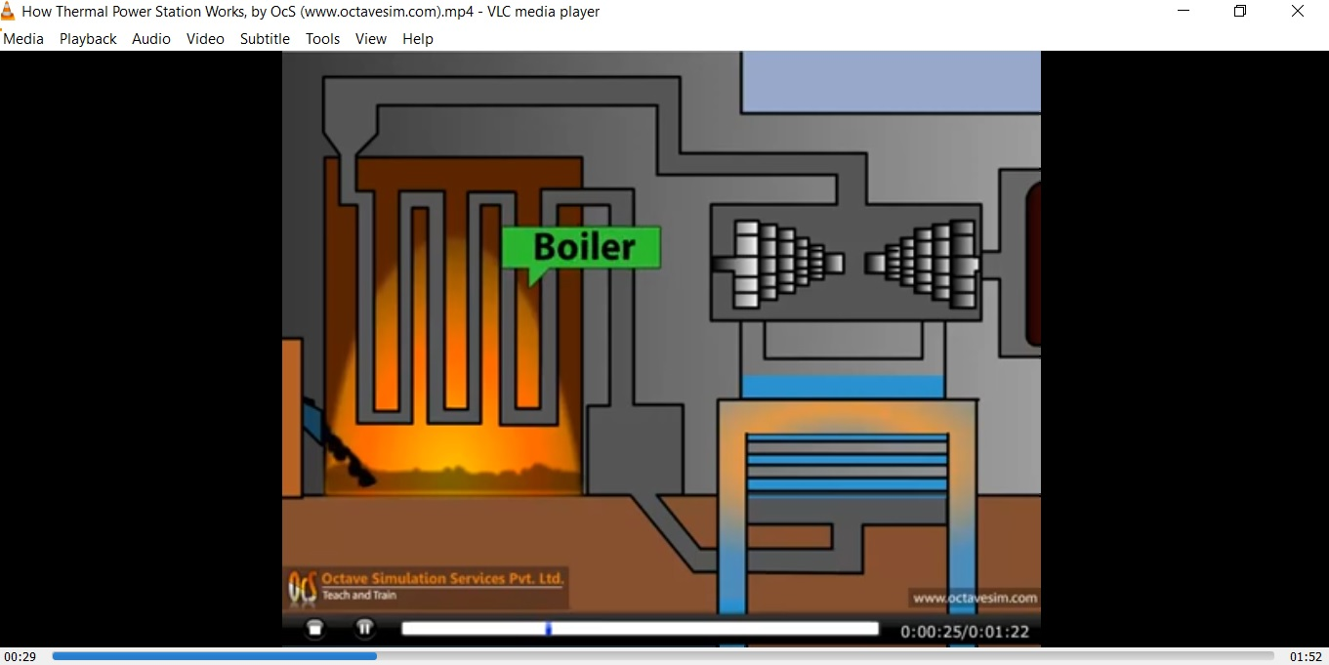

Figure 5.6.7 Animation video for thermal power station

- Demo Models
Demo models are practical tools that help students visualize and interact with abstract concepts, making them easier to understand. By physically or digitally demonstrating how a concept works, students can directly observe cause-and-effect relationships.
These models encourage hands-on learning, allowing students to manipulate variables and see real-time results. Demo models simplify complex theories by breaking them into manageable, tangible steps. They foster active learning, where students engage, experiment, and ask questions, enhancing their understanding.
Figure 5.6.8 shows images Demo models for dynamics of machinery.
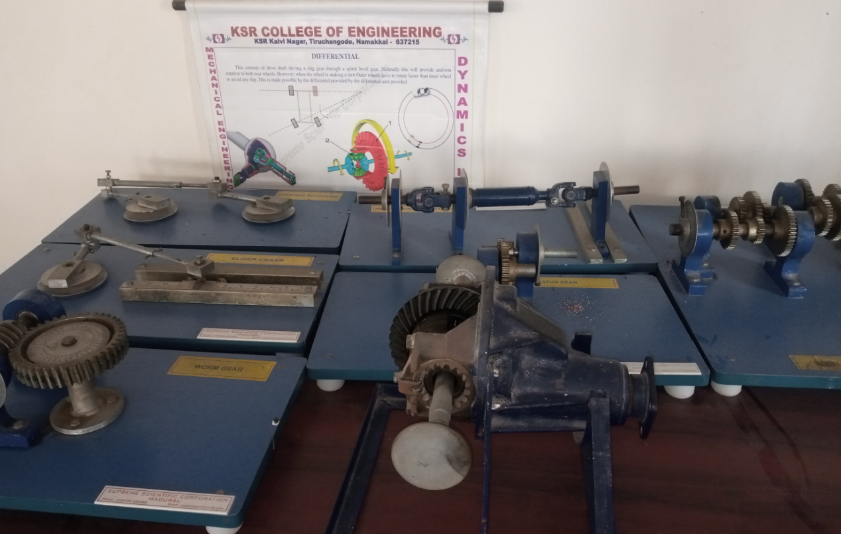
Figure 5.6.8 Demo models in Dynamics of machinery
8. Video demo class
Video classes are a highly effective tool for student learning, providing a visual and auditory way to engage with educational content.
Video Classes are classrooms on an online platform that takes place via the internet. These classes are very informative and give other ideas apart from the curriculum.

1. Visual Learning
Video classes help break down complex concepts into easily digestible segments. Visual aids such as diagrams, animations, and real-life examples can make difficult topics more accessible.
Subjects that require step-by-step procedures (e.g., mathematics, science experiments, coding) are effectively taught through video demonstrations.

2. Flexible Learning
Video classes can be accessed anytime and anywhere, allowing students to learn at their own pace. They can pause, rewind, and replay content as needed to fully understand the material.
This flexibility is especially beneficial for students with varied schedules or those in remote locations, as they don’t have to attend live sessions.
Separate classes are assigned for the students to refresh and enhance their knowledge. In every video class different kinds of topics were focused and the overall topic was covered with appropriate video clips.

Figure 5.6.9. visualize the student’s active participation and interaction with faculty.
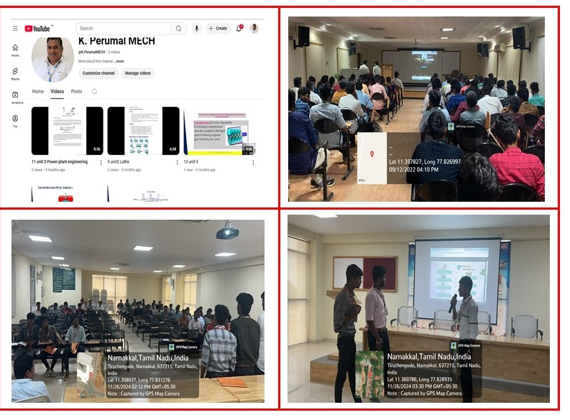
Figure 5.6.9 Video Demo Class in different venue
9.E-Learning

Students and faculty members are encouraged to register for the NPTEL program/ online certification courses of their own areas of teaching and research interests, for enhancing their teaching skills, smooth conduct of the teaching process in the regular class room teaching and for understanding the potential concepts much effectively.

Faculty members are also made as mentors for providing support to the students to complete the course. The students who have not registered for any courses are supported by providing the NPTEL video lectures in the central digital library.

Faculty members and students are encouraged to complete courses in various online platforms like Coursera, and future skills. Many number of courses were completed by our faculty members and students.
Figure 5.6.10. Shows NPTEL and Coursera certificate for faculty and students.
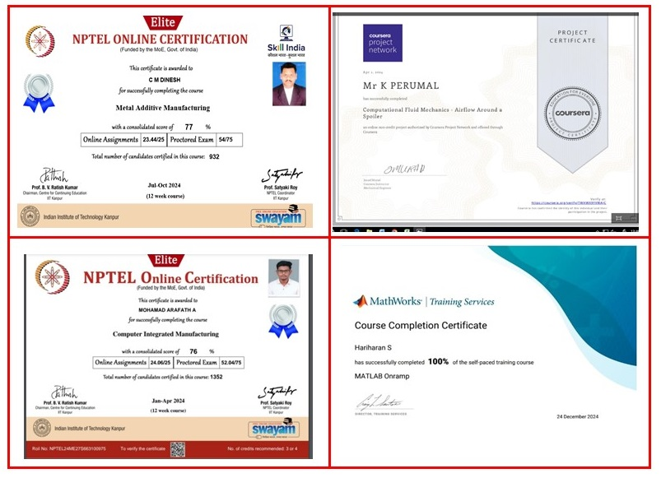
Figure 5.6.10. NPTEL and Coursera certificate for faculty and students.

S.No | Name of the e-Journal Publisher | URL Address
1. | IEEE ASPP(All Society Periodicals) | www.ieeexplore.ieee.org
2. | American Society of Mechanical Engineers (ASME) | http://asmedigitalcollection.asme.org
3. | Elsevier - Mechanical Engineering | www.sciencedirect.com
4. | Institution of Engineering and Technology(IET) | http://digital-library.theiet.org
5. | ISO JTC 1 | http://standards.bsbedge.com
6. | J-Gate Engineering | https://jgateplus.com/search/
7. | J-Gate Management | https://jgateplus.com/search/
8. | Springer Link | https://link.springer.com/
9. | Institution of Engineers India (IEI) | http://digital-library.theiet.org
10. | McGraw Hill Engineering Library | https://www.accessengineeringlibrary.com/
11. | ASTM Digital Library | https://compass.astm.org/CUSTOMERS/index.html
10. Google document
Google Documents is an excellent tool for student project-based learning, allowing students to collaborate and share ideas in real time. It enables multiple students to work on the same document simultaneously, making teamwork more efficient and productive. Students can create, edit, and format documents together while leaving comments or suggestions for one another.
The cloud-based nature of Google Docs ensures that students can access their projects from any device, anytime, without worrying about losing their work. Teachers can provide real-time feedback directly in the document, guiding students through revisions. It also integrates with other Google tools, like Google Drive, for easy access to resources. Google Docs fosters peer collaboration, improves communication, and helps students stay organized throughout the project. Ultimately, it empowers students to work effectively together and enhance their project-based learning experience
Figure 5. 6.11. Shows Google documents student’s active participation and interaction with faculty.

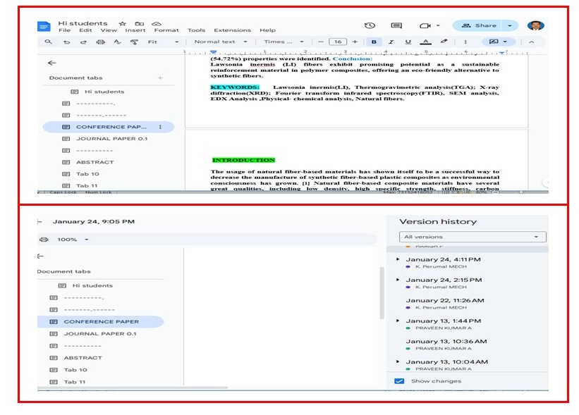
Figure 5. 6.11. Shows Google documents student project work updated
11. Flipped Classroom

Flipped Classroom students engage in a learning model where traditional lectures are reversed. Instead of passive listening in class, students first explore content independently at home, usually through videos or reading materials. Classroom time is then dedicated to active learning, discussion, and problem-solving.
This approach encourages deeper understanding and critical thinking, as students apply concepts with guidance from their teacher. It also promotes collaboration, as students often work together on assignments or projects. The flipped model allows for personalized learning, where students can progress at their own pace. Overall, it fosters a more interactive, student-centered learning environment.
Figure 5. 6.12. Shows Flipped Classroom student’s active participation.
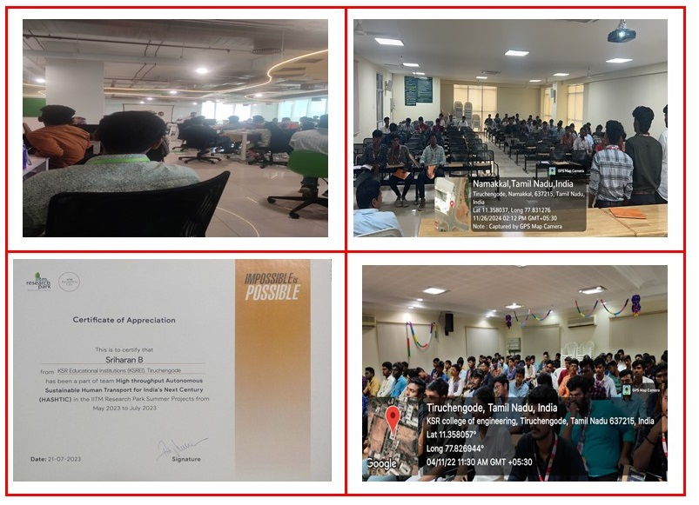
Figure 5. 6.12. Shows Flipped Classroom student’s active participation.
12. Student-Centric teaching methodologies
Student-centric teaching methodologies prioritize the needs, interests, and learning styles of students. In this approach, teachers act as facilitators rather than just providers of knowledge. Students take an active role in their learning process, engaging in activities like group discussions, problem-solving tasks, and hands-on experiments. The focus is on collaboration, critical thinking, and the development of skills such as creativity and communication.
Technology plays a significant role in student-centric learning, enabling personalized learning experiences and providing various tools for interactive learning. Assessments in this approach are often formative, giving students regular feedback to guide their progress. It emphasizes self-directed learning, where students have the autonomy to explore topics at their own pace. The learning environment is often flexible, encouraging curiosity and fostering a sense of ownership over one’s education.
This methodology promotes a deeper understanding of the subject matter, as students are encouraged to make connections and apply their knowledge to real-world scenarios. Ultimately, student-centric learning aims to develop lifelong learners who are equipped with the skills necessary to thrive in an ever-changing world.
Figure 5. 6.13. Shows Student-Centric teaching methodologies active participation and interaction with faculty.
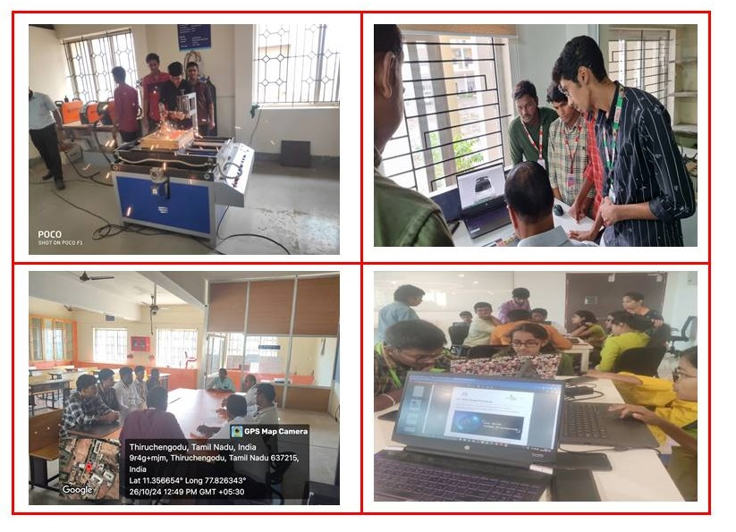
Figure 5. 6.13. Shows Student-Centric teaching methodologies

Faculty Incharge HoD/ Mech

